Data Engineering

Types of Services in Azure
In Azure Data Engineering, IaaS provides full control using virtual machines, PaaS offers managed data services like ADF, Databricks, and Synapse, while SaaS delivers ready-to-use analytics solutions like Power BI
IaaS in Azure Data Engineering
Example: Azure Virtual Machine
What you do:
- Create VM
- Install OS
- Install SQL Server
- Configure storage
- Apply patches
- Handle scaling & backups
PaaS in Azure Data Engineering (MOST COMMON)
Example: Azure Data Factory + ADLS + Databricks + Synapse
What you do:
- Write pipelines
- Write transformations
- Model data
- Create reports
SaaS in Azure Data Engineering
Example: Power BI Service
What you do:
- Upload dataset
- Build reports
Blob Storage vs ADLS Gen2 Storage
Blob stands for Binary Large Object. A blob is an individual file stored as an object in Azure Blob Storage, used to store unstructured or semi-structured data such as images, logs, or data files.
A blob can store any type of data, for example:
- Images (.jpg, .png)
- Videos (.mp4)
- Documents (.pdf, .docx)
- Logs (.log)
- CSV / JSON / Parquet files
- Backups
Azure doesn’t care what’s inside — it treats it as binary data.
Azure Data Lake Storage Gen2 (ADLS Gen2) = Azure Blob Storage + Big Data capabilities
Container: images
├── img1.jpg
├── img2.png
Azure Data Lake Storage (ADLS Gen2)
Example Azure Data Lake structure:
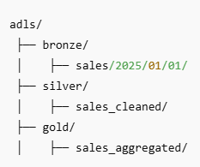
The Hierarchical Namespace feature enables ADLS Gen2 to support Big Data workloads by providing true directory structures, efficient metadata operations, and native compatibility with Hadoop and Spark, which plain Blob Storage lacks.
Big Data tools REQUIRE HNS
Big Data frameworks like:
- Apache Spark
- Hadoop
- Databricks
- Synapse Spark
expect:
- Fast directory listing
- Rename / move folders
- Permission inheritance
Deploy a Storage Account
storagetrainadls
Sqladminuser/Fedex@54321
Deploy a Synapse workspace – synapse-azure-training
At the time of creating the synapse workspace, it will ask for a storage account, which will be treated as synapse’s internal storage account. You may create a new adls storage(storagesyntrainadls) during that time.
We always use external storage with synapse, hence we will use storagetrainadls
Once we login to the Synapse, under Data Linked section, we will be able to see all the existing Linked services. At this moment, the only linked service is the internal storage account that synapse created at the time of deployment.
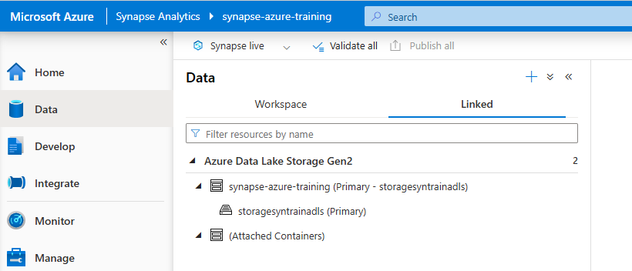
Create a new Linked Service to the external Data Lake
Manage Linked Service + New Search Azure Data Lake Storage Gen2
